Faculty of Computing

IT2120 – Probability and Statistics

Lab Sheet 05

IT24104143 – Perera H.G.K.D

1. Import the dataset (’Exercise – Lab 05.txt’) into R and store it in a data frame called ”Delivery Times”.

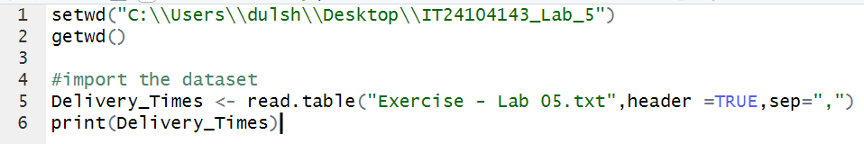

1. Draw a histogram for deliver times using nine class intervals where the lower limit is 20 and upper limit is 70. Use right open intervals.

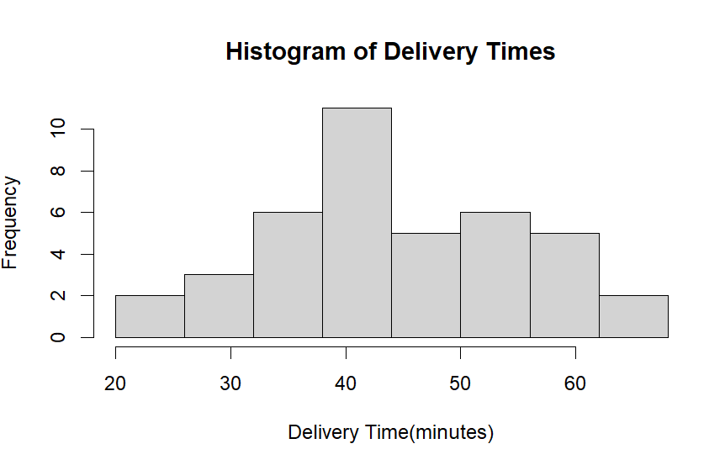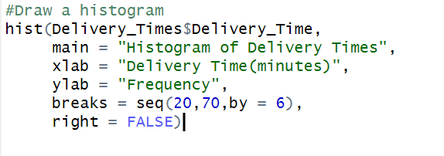

3) Comment on the shape of the distribution

The distribution of delivery times is right skewed, with the majority of delivery times falling between 30 and 45 minutes. A few higher values (above 50 minutes) extend the tail to the right.

4) Draw a cumulative frequency polygon (ogive) for the data in a separate plot.



